# R1

Router>enable

Router#config t

Enter configuration commands, one per line. End with CNTL/Z.

Router(config)#int serial 0/0/0

%Invalid interface type and number

Router(config)#interface serial 0/0/0

%Invalid interface type and number

Router(config)#exit

Router#

%SYS-5-CONFIG_I: Configured from console by console

Router#config t

Enter configuration commands, one per line. End with CNTL/Z.

Router(config)#interface serial 0/0/0

%Invalid interface type and number

Router(config)#interface serial 1/0

%Invalid interface type and number

Router(config)#interface serial 0/0

%Invalid interface type and number

Router(config)#interface serial 0/1/0

Router(config-if)#ip address 192.168.1.1 255.255.255.0

R1(config-if)#clock rate 64000

Router(config-if)#no shutdown

%LINK-5-CHANGED: Interface Serial0/1/0, changed state to down

Router(config-if)#exit

Router(config)#hostname R1

R1(config)#

R1(config)#interface fastethernet 0/1

R1(config-if)#ip address 192.168.10.1

% Incomplete command.

R1(config-if)#ip address 192.168.10.1 255.255.255.0

R1(config-if)#no shutdown

R1(config-if)#

%LINK-5-CHANGED: Interface FastEthernet0/1, changed state to up

# R2

Router>enable

Router#config t

Enter configuration commands, one per line. End with CNTL/Z.

Router(config)#hostname R2

R2(config)#interface serial 0/1/0

R2(config-if)#ip address 192.168.1.2 255.255.255.0

R2(config-if)#no shutdown

R2(config-if)#

%LINK-5-CHANGED: Interface Serial0/1/0, changed state to up

R2(config-if)#

%LINEPROTO-5-UPDOWN: Line protocol on Interface Serial0/1/0, changed state to up

R2(config-if)#exit

R2(config)#interface fastethernet 0/1

R2(config-if)#ip address 192.168.2.1 255.255.255.0

R2(config-if)#no shutdown

R2(config-if)#

%LINK-5-CHANGED: Interface FastEthernet0/1, changed state to up

R2(config-if)#exit

R2(config)#

# R3

Router>enable

Router#config t

Enter configuration commands, one per line. End with CNTL/Z.

Router(config)#interface serial 0/1/0

Router(config-if)#ip address 192.168.3.1 255.255.255.0

Router(config-if)#no shutdown

%LINK-5-CHANGED: Interface Serial0/1/0, changed state to down

Router(config-if)#exit

Router(config)#interface fastethernet 0/1

Router(config-if)#ip address 192.168.4.1 255.255.255.0

Router(config-if)#no shutdown

Router(config-if)#

%LINK-5-CHANGED: Interface FastEthernet0/1, changed state to up

Router#

%SYS-5-CONFIG_I: Configured from console by console

Router#config t

Enter configuration commands, one per line. End with CNTL/Z.

Router(config)#hostname R3

R3(config)#

# Assigning IP Addresses to PCs

## End Terminal at R1

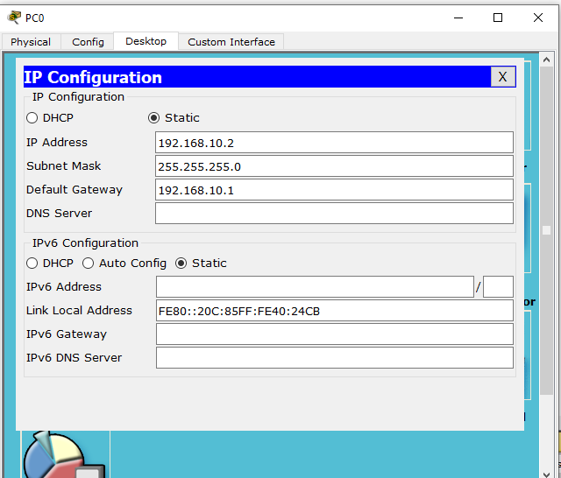

## End Terminal at R2

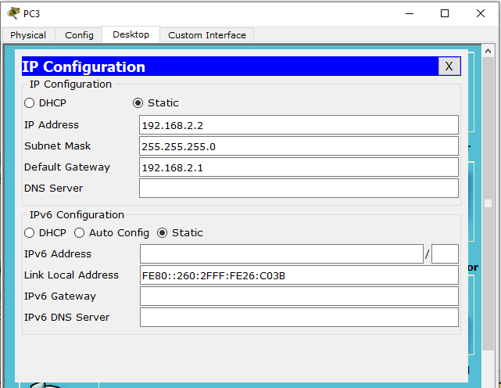

## End Terminal at R3

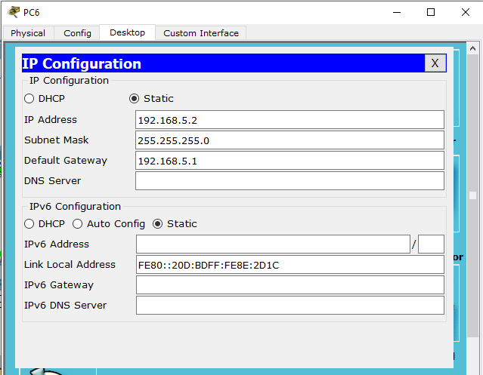

# Network Structure

